
Getting ready for Secondary School!


Moving to Secondary School is both exciting and scary! You will meet new teachers, make new friends, and get used to a new routine. This workbook will help you to manage all of those changes.
Life is a journey! Think back through primary school and write down your favourite memories or events that have shaped you to become the amazing person you are!
My Journey so far


………………………………………………………………………………………………………………………………………………………………………………………………………………………………………………………………………………………………………………………………………………………………………………………………………………………………………………………………………………………………………………………………………………………………………………………………………………………………………………………………………………………………………………………………………………………………………………………………………………………………………………………………………………………………

What Others Say About Me
Fill these speech bubbles with positive things your friends, family, and teachers would say about you!

My Secondary School
My new school’s name: ......................................................................
School address:……………………………………………………….
School telephone number: .................................................................
Head Teacher’s Name: ........................................................................
New Form Tutor’s Name: ...................................................................

This is an example of what a time table may look like…..
 | Monday | Tuesday | Wednesday | Thursday | Friday
Tutor |  | ASSEMBLY
Period 1  08:50-09:40 | MATHS  TAS B4 | SCIENCE  ECU D11 | ENGLISH  JTR B10 | CATERING  DMI D2 | PE  LSA Hall
Period 2 09:40-10:30 | ENGLISH  JTR B10 | MATHS  TAS B4 | HISTORY  ZCB D3 | CATERING  DMI D2 | PE  LSA Hall
BREAK 10:30-10:50
Period 3  10:50-11:40 | GEOGRAPHY  SKO D9 | ENGLISH  JTR B10 | ETHICS  VDI A5 | ETHICS  VDI A5 | MATHS  TAS B4
Period 4  11:40-12:30 | SCIENCE  ECU D11 | ENGLISH  TOB LRC | MATHS  TAS B4 | SCIENCE  ECU D11 | GEOGRAPHY  SKO D9
LUNCH 12:30-13:00
Period 5  13:00-13:50 | COMPUTING  THU A3 | ART  TMI B8 | DRAMA  ARO Studio | ETHICS  VDI A5 | ENGLISH  JTR B10
Period 6  13:50-14:40 | SPANISH  EFB B11 | TEXTILES  DMI E3 | DANCE  KWA Studio | MUSIC  TMO E2 | HISTORY  ZCB D3
Extra-Curricular  14:40-15:40 |  | DRAMA CLUB |  |  | FITNESS CLUB


- You will get a timetable for your school year on the first day of term.
- You may want to keep this safe in your organiser/planner.
- It may help to keep your books organised for bringing them into school.
- You may want to fill in the time table below – if you find it helpful
 | Monday | Tuesday | Wednesday | Thursday | Friday
Tutor
Period 1

Period 2
BREAK
Period 3

Period 4

LUNCH
Period 5

Period 6

Moving to Secondary School
Write up to four things you are excited about!

Moving to Secondary School
Write up to four things you are worried or nervous about…

Moving to Secondary School
Write up to four things that you help you feel better about moving school…

How I feel…
Tick whether you feel ‘okay’ or ‘not so okay’ about the following things…

 | Okay | Not So Okay
Finding my way around school
Making new friends
Break times
Lunch times
Wearing a new uniform
Learning new subjects
School rules
Meeting new teachers
Homework
Travelling to school
Being with older students
Getting changed for PE
Using the school toilets

If there is anything you are worried about, you can speak to your new form tutor or someone from the pastoral support team.

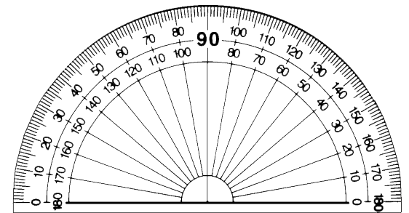
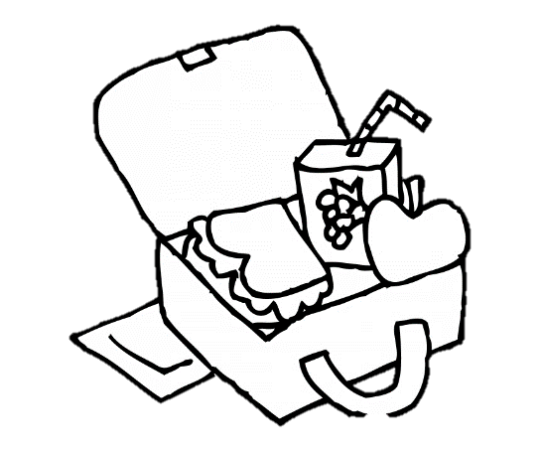



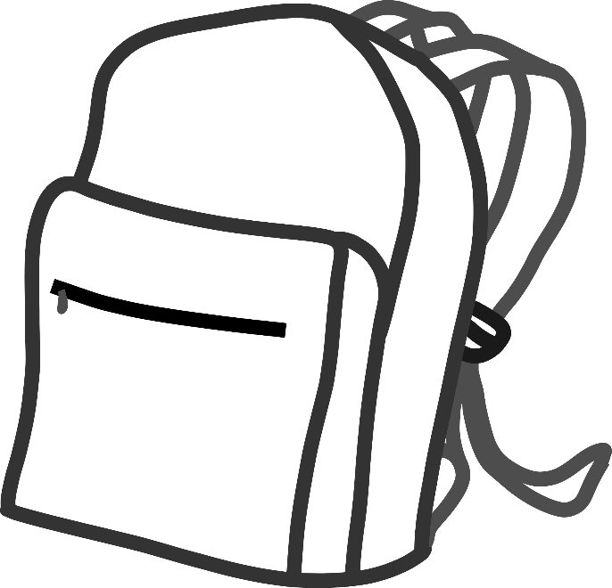


Equipment…
These are some of the items you will need in your bag each day. Colour them in and use this page as a reminder for when you pack your school bag.

My Journey to School
Write down how you will get to school, what time you will need to leave, and what time you expect to arrive at school

- ...............................................................................................
- ...............................................................................................
- ...............................................................................................
- ...............................................................................................
Now that you know the quickest and safest route you will take to school, let’s arrange a date and time to practice this journey.

Date: ...............................................................................................
Time I will leave: .............................................................................
How long will it take? .....................................................................
Who will come with me? .....................................................................




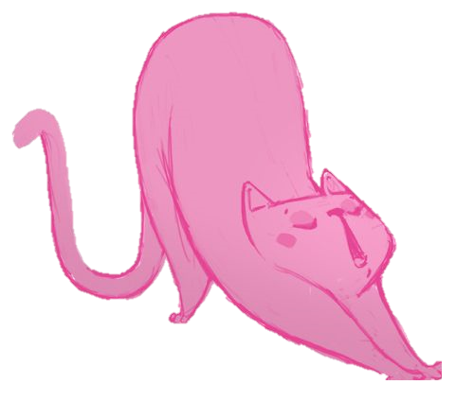
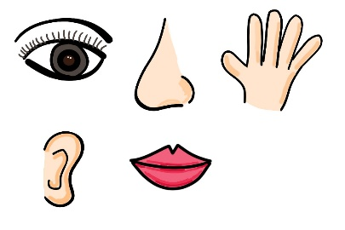
Relaxation Techniques

The Big Squeeze
This exercise relaxes the tension your muscles. Squeeze each of these body parts for 5 seconds and then release it.
Hands and arms, arms and shoulders, shoulders and neck, jaw, face and nose, stomach, legs and feet.
Making Lemonade
Imagine reaching up high and picking lemons from a tree with both hands. Squeeze the lemons in your fists until all the juice is out. Throw the lemons on the floor. Repeat until you have enough lemonade.
The Flower and The Candle
This exercise helps us take deep breaths.
Breathe in slowly through your nose as if you’re smelling a flower. Breathe out slowly through your mouth as if you’re blowing out a candle. Repeat a few times.
The Five Senses
This is a grounding technique. List 5 things you can see
4 things you can feel 3 things you can hear
2 things you can smell 1 thing you can taste

My Goals for secondary school

My dream : .....................................................................................
……………………………………………………………
…………………………………………………………………………………………………………………………………………………………
When you go to secondary school, you will learn a huge number of new skills, and improve skills you have practiced in primary school. Write in the goal… some of the things you would like to achieve at secondary school.
